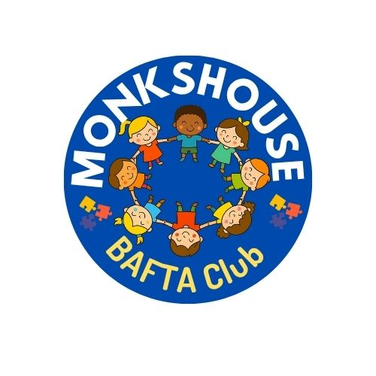

BAFTA Booking Information

Bookings for BAFTA will be made via Arbor, using the Parent Portal or App.
- Go to your child’s profile → Activities → Clubs. Select either Breakfast Club or Afterschool Club (which offers 5 session options at £4/hour).
- To pay: go to Accounts → BAFTA Club Payments → Top Up Account. You must top up enough to cover all booked sessions.
- Booking closes 1 week before each session. If a date isn’t available, the club is full.
- Sessions cannot be cancelled or moved via the portal/app. To cancel with 24 hours’ notice and request a refund, please speak to the school office or email reply@monkshouse.co.uk. Approved refunds will be credited to your top-up account.

Tax-Free Childcare Voucher Payments
If you pay using Tax-Free Childcare Vouchers, these go directly to the school’s bank account. You can still book sessions without card payment. Once received, the school will credit your top-up account.
Your BAFTA account may temporarily show a balance due, but this should clear within 7 days.

